C PROGRAMMING TO CHECK AND COUNT NUMBER OF TIMES BUBBLES ARE PRESENT IN GIVEN STRING

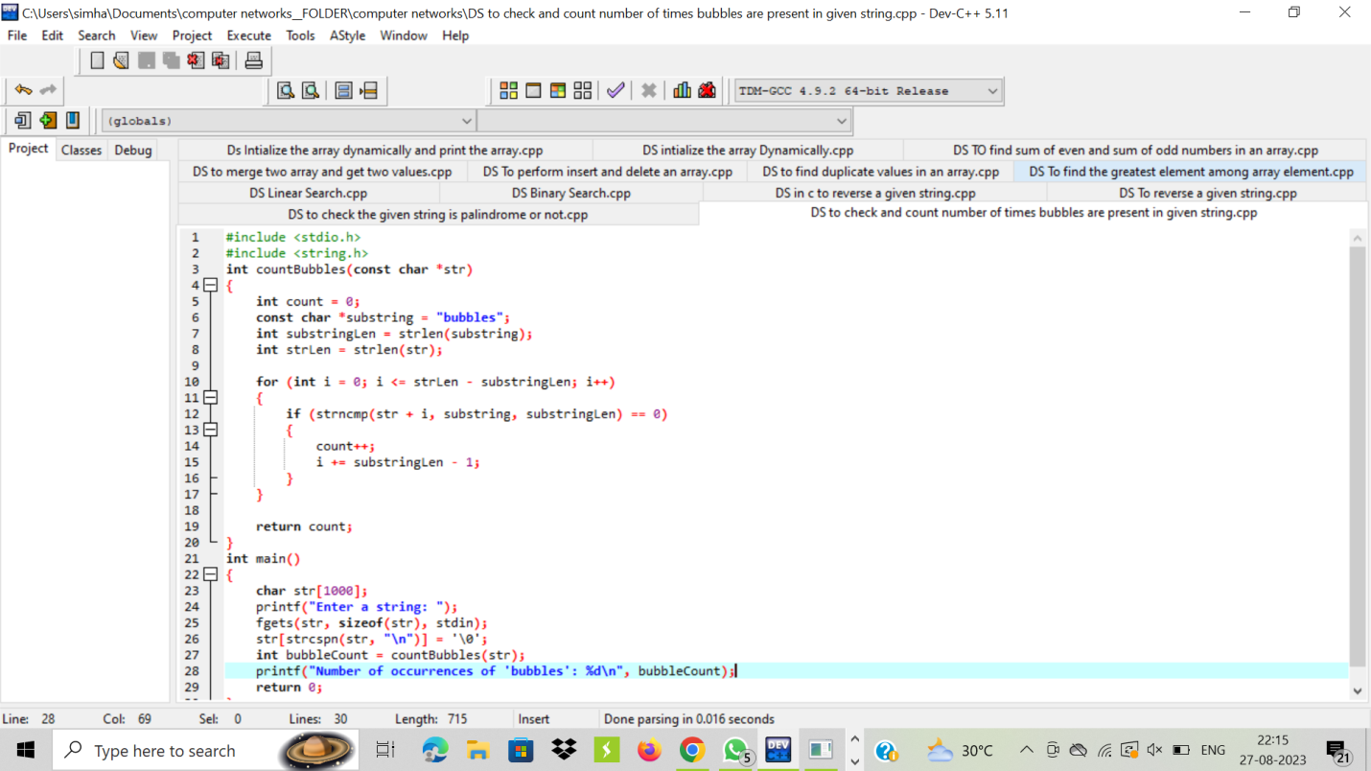

OUTPUT:

